Alexander Baldree
06/17/26
Module 3.2 Assignment
CSD430

GitHub Link:
https://github.com/Panda-Alex21687/CSD430

Baldre3JSP inside webapps
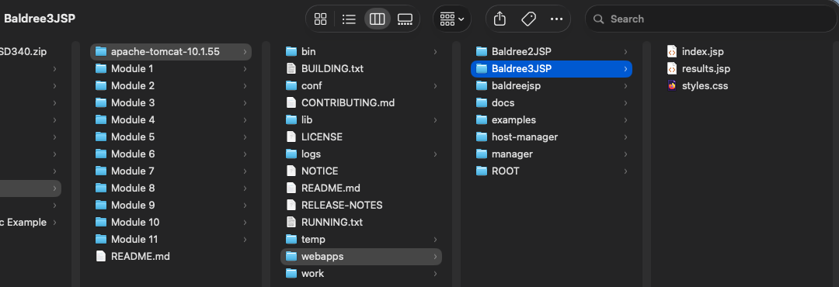

index.jsp opened in VSC:
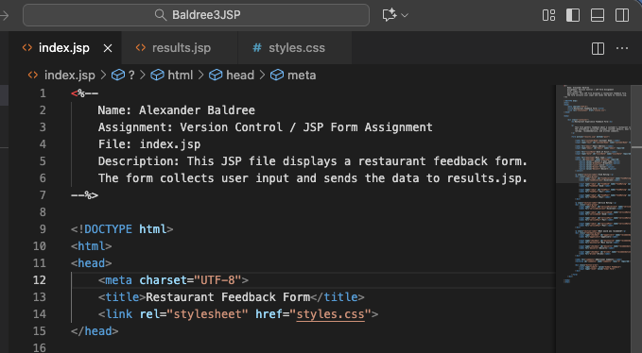

results.jsp opened in VSC:
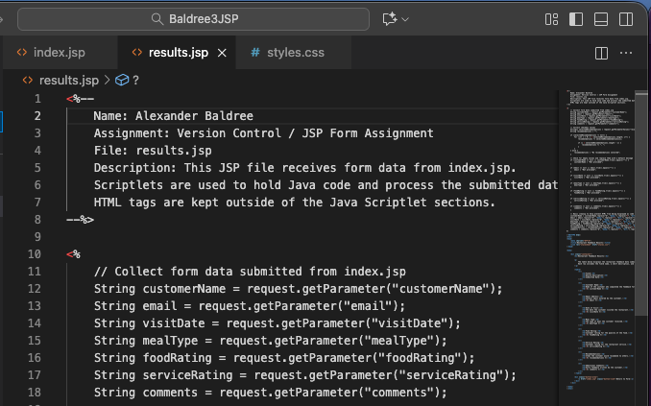
styles.css opened in VSC:
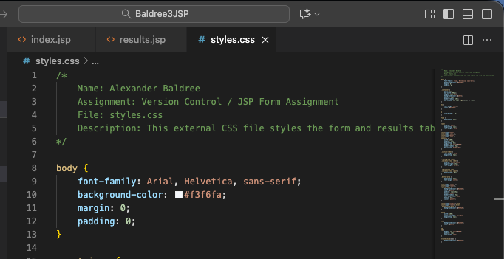

Feedback Form running in browser:
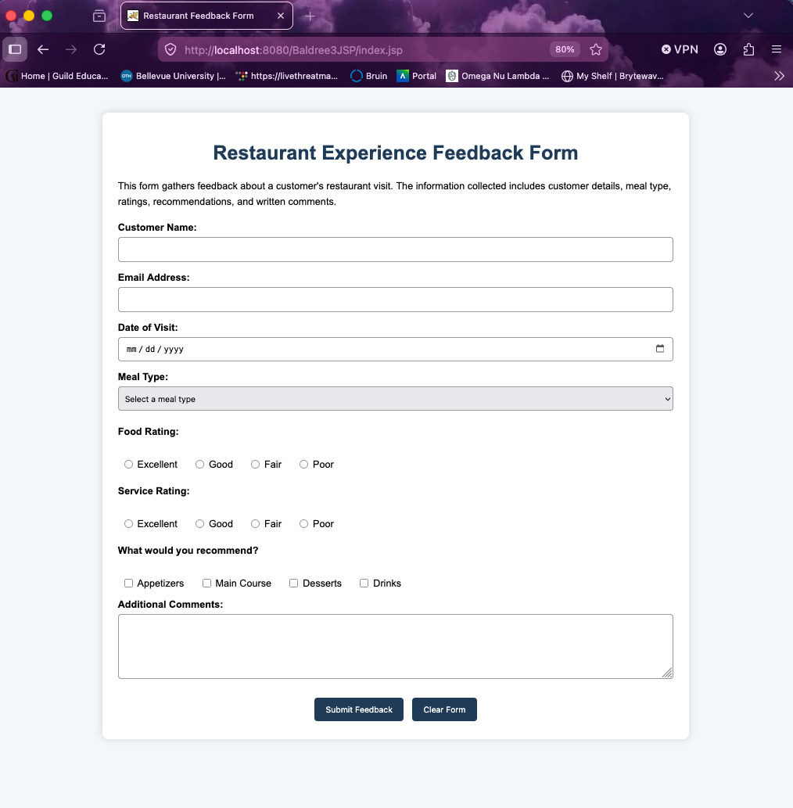

Form Filled out before Submitting:
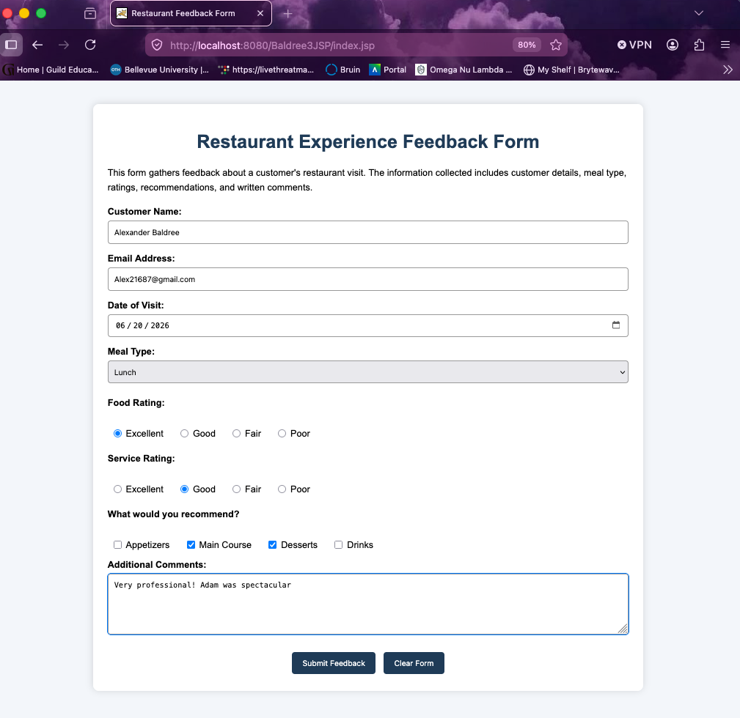

Results from submitting form:
